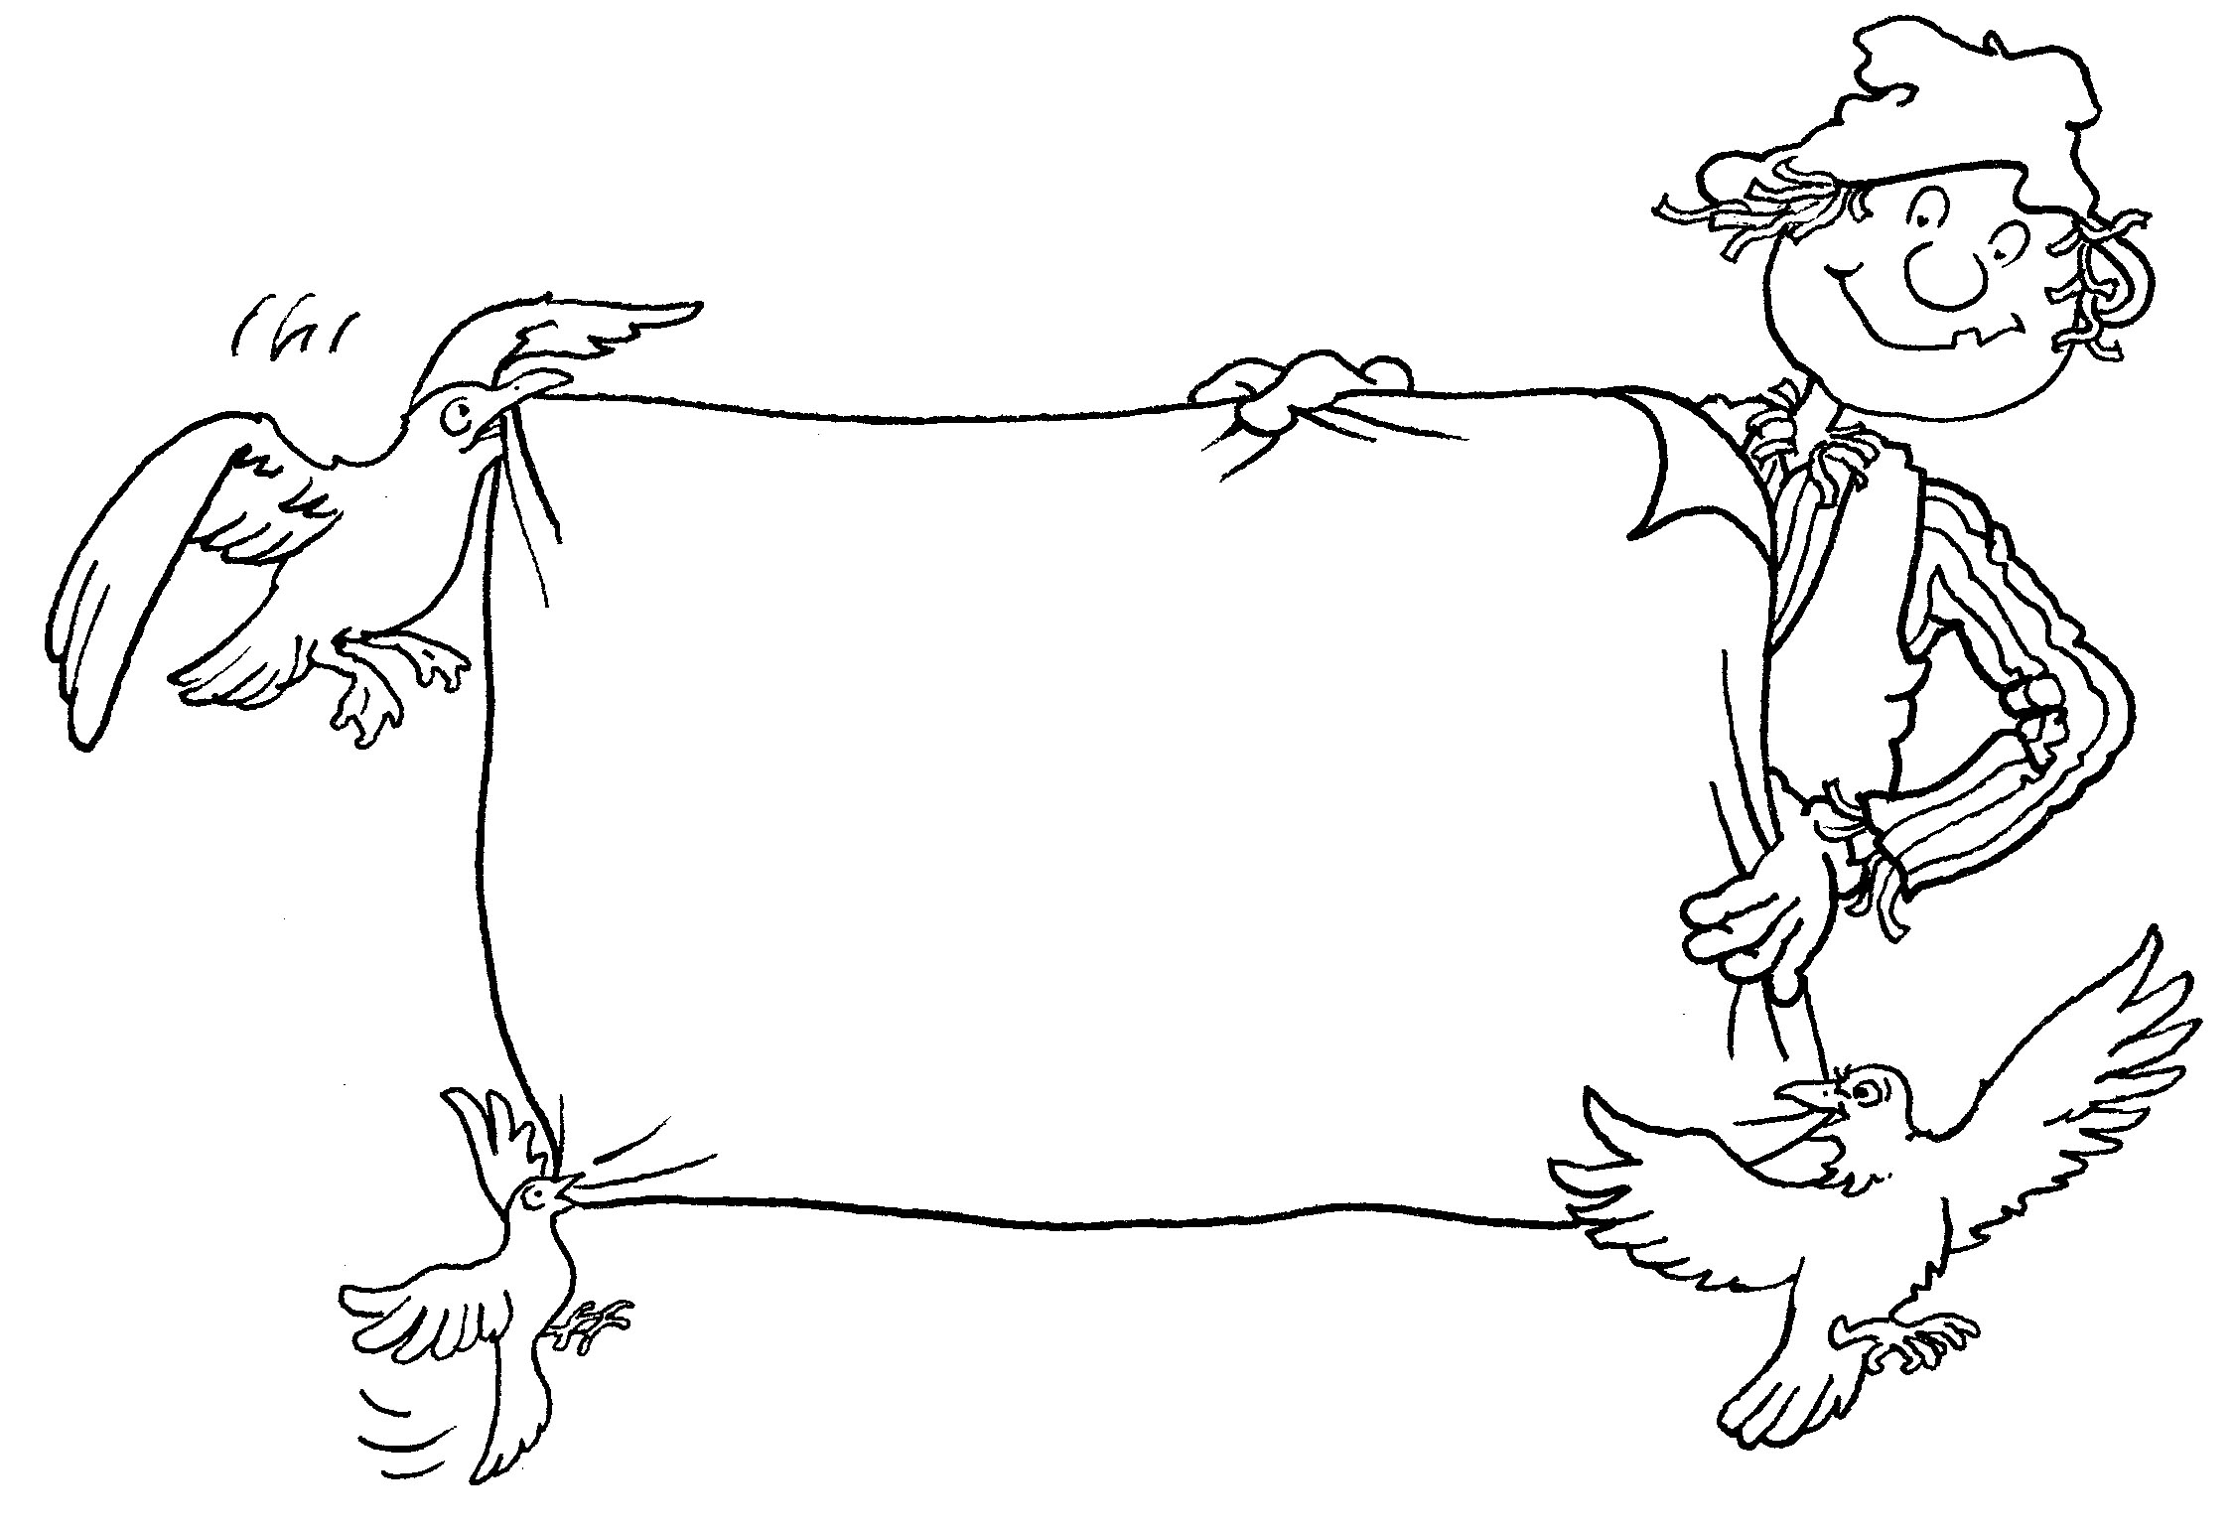
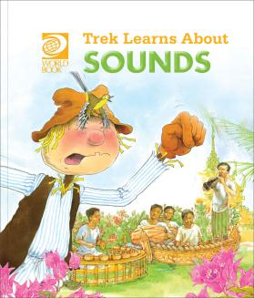
Trek’s Travels –

SOUNDS

Sounds of the city
1. Can you remember what sounds Trek heard in the city?
_________________________________________________________________
2. What makes a ringing sound?
_________________________________________________________________
3. What makes a tooting sound?
_________________________________________________________________
4. What other sounds would you hear in the city?
_________________________________________________________________

Sounds of the market
1. What sounds did Trek hear in the market?
_________________________________________________________________
2. What makes a cackling sound?
_________________________________________________________________
3. What makes a clucking noise?
_________________________________________________________________
4. What other sounds would you hear in the market?
_________________________________________________________________

Musical sounds
1. Do you like listening to music?
_________________________________________________________________
2. What did Trek hear that made a clashing sound?
_________________________________________________________________
3. What did Trek hear that made a tooting sound?
_________________________________________________________________
4. Can you make any musical sounds?
_________________________________________________________________

Stormy sounds
1. Have you ever heard a storm?
_________________________________________________________________
2. Can you make a whistling noise like the wind?
3. Can you make a swishing noise like leaves blowing in the wind?
4. Can you make a plopping sound like rain hitting the ground?

Sounds of the forest
1. What sounds did Trek hear in the forest?
_________________________________________________________________
2. What makes a chirruping sound?
_________________________________________________________________
3. What makes a croaking sound?
_________________________________________________________________
4. What other sounds would you hear in the forest?
_________________________________________________________________
5. Can you chatter like a monkey?
_________________________________________________________________

ACTIVITY –

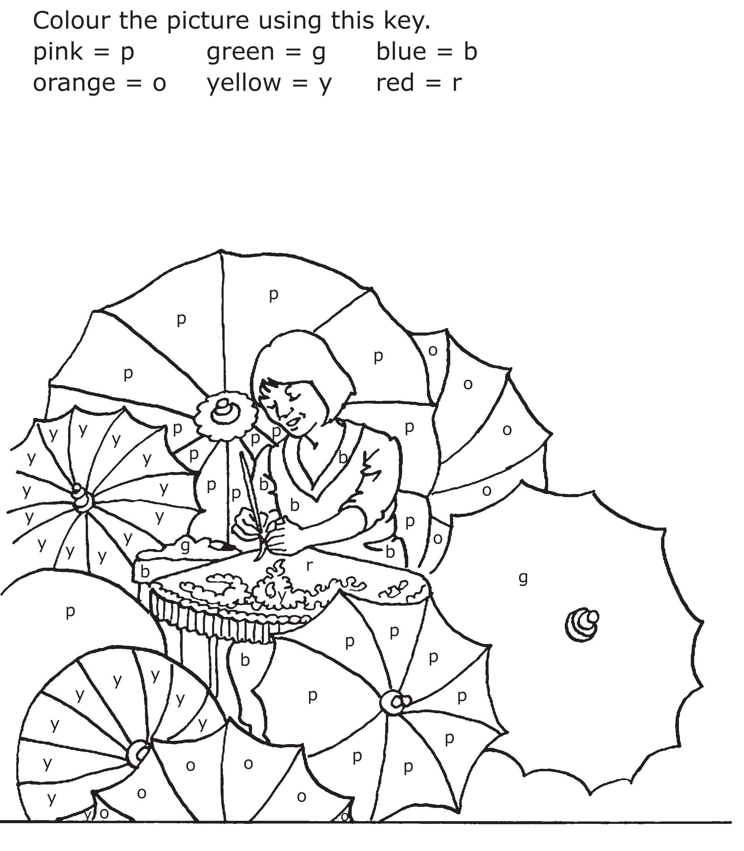

Aim: to recognise colours and learn to follow a key.

Trek’s World Travels
Where in the world does Trek learn about sounds?
Thailand

