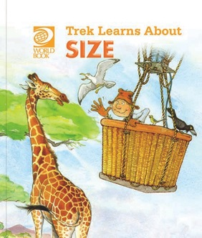
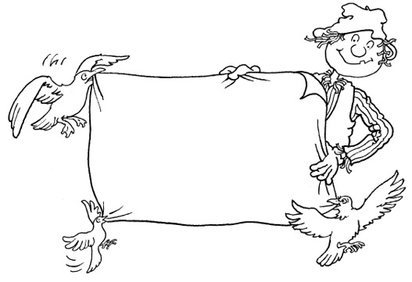
Trek’s Travels –

SIZE

Talking about size
1. Can you find a big animal?
_________________________________________________________________
2. Can you find a small animal?
_________________________________________________________________
3. Which animals have long legs?
_________________________________________________________________
4. Which animals have long necks?
_________________________________________________________________
5. Why can the giraffe eat leaves from the tree tops?
_________________________________________________________________6. Can you see an animal with big teeth?
_________________________________________________________________7. Can you see an animal with little teeth?
_________________________________________________________________
Comparing sizes
1. Is the balloon as big as the elephant?
_________________________________________________________________
2. Which is the tallest animal?
_________________________________________________________________
3. Which is the fattest animal?
_________________________________________________________________4. Which is the thinnest animal?
_________________________________________________________________5. Can you find an animal that could fit into the balloon basket?
_________________________________________________________________6. Can you find an animal that could not fit into the balloon basket?
_________________________________________________________________

ACTIVITY –
Colour the tallest giraffe.
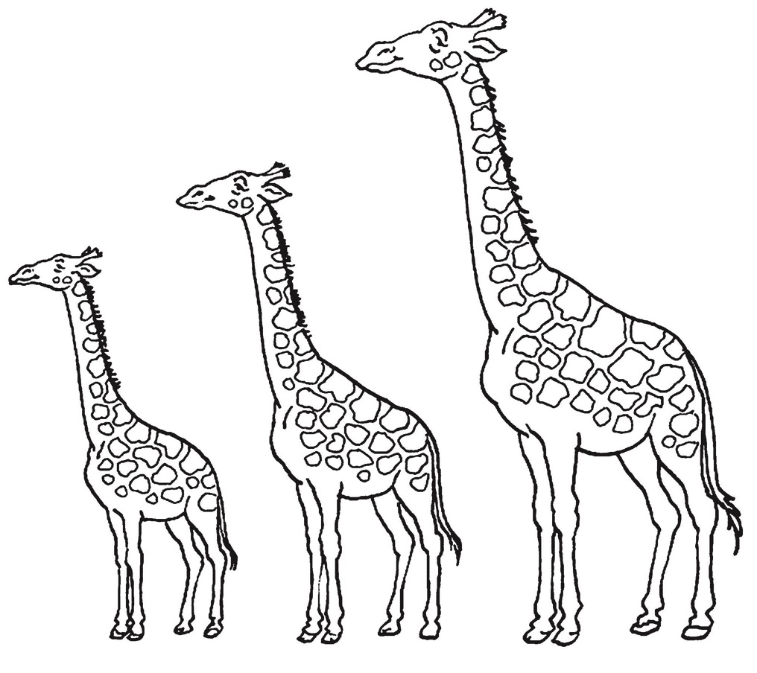

Aim: to understand the language of size.
ACTIVITY –

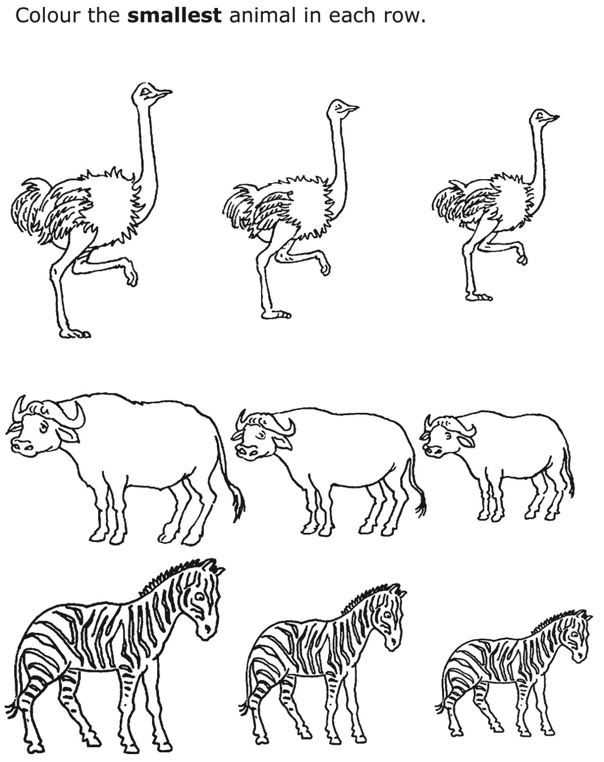

Aim: to understand the language of size.
ACTIVITY –

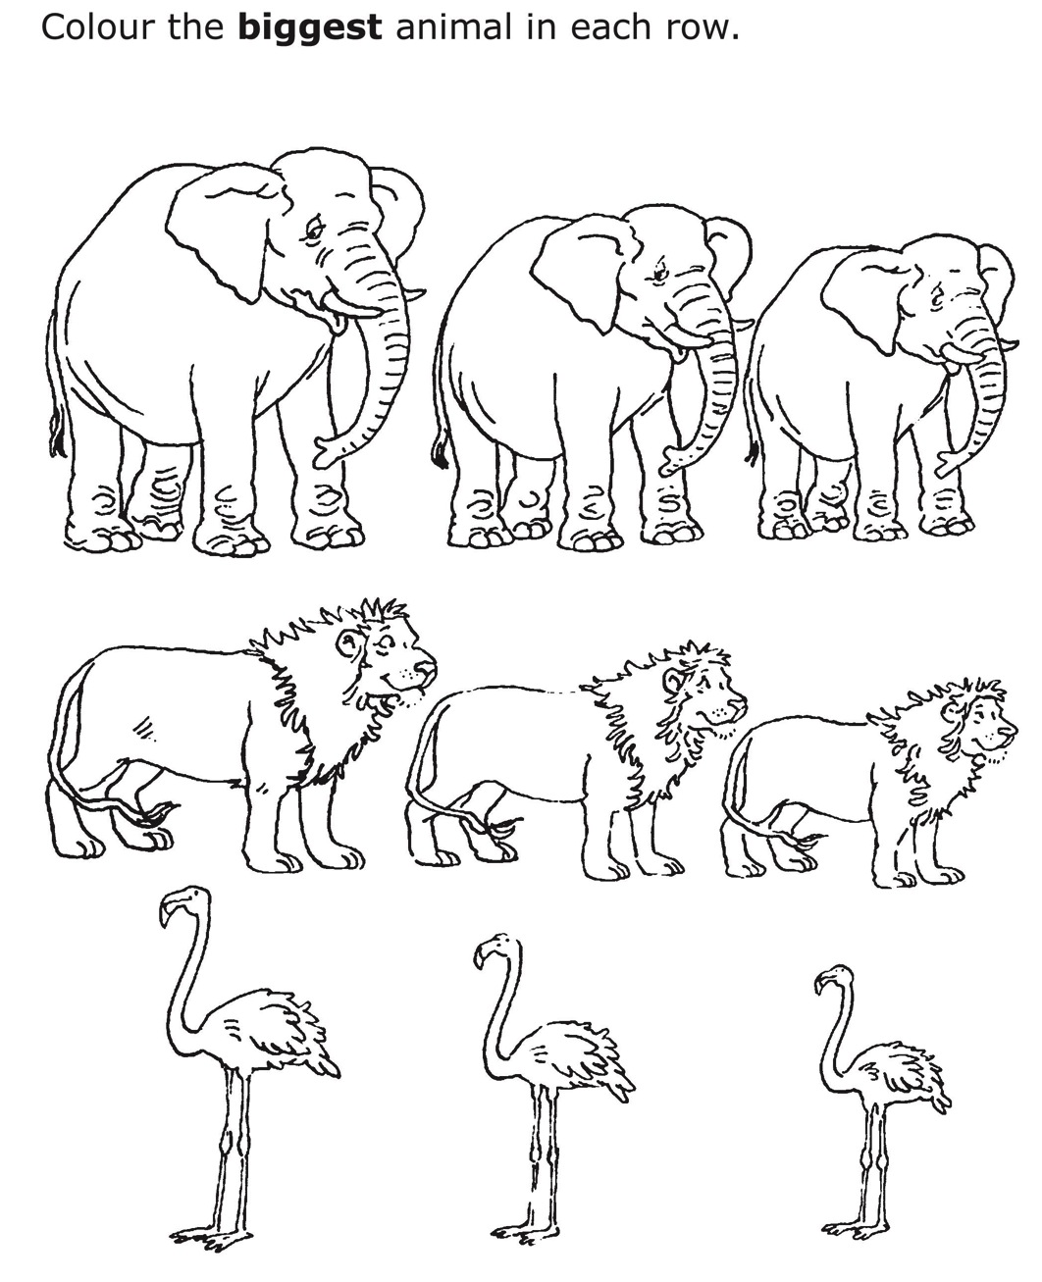

Aim: to understand the language of size.
Trek’s World Travels
Where in the world does Trek learn about size?
Africa

