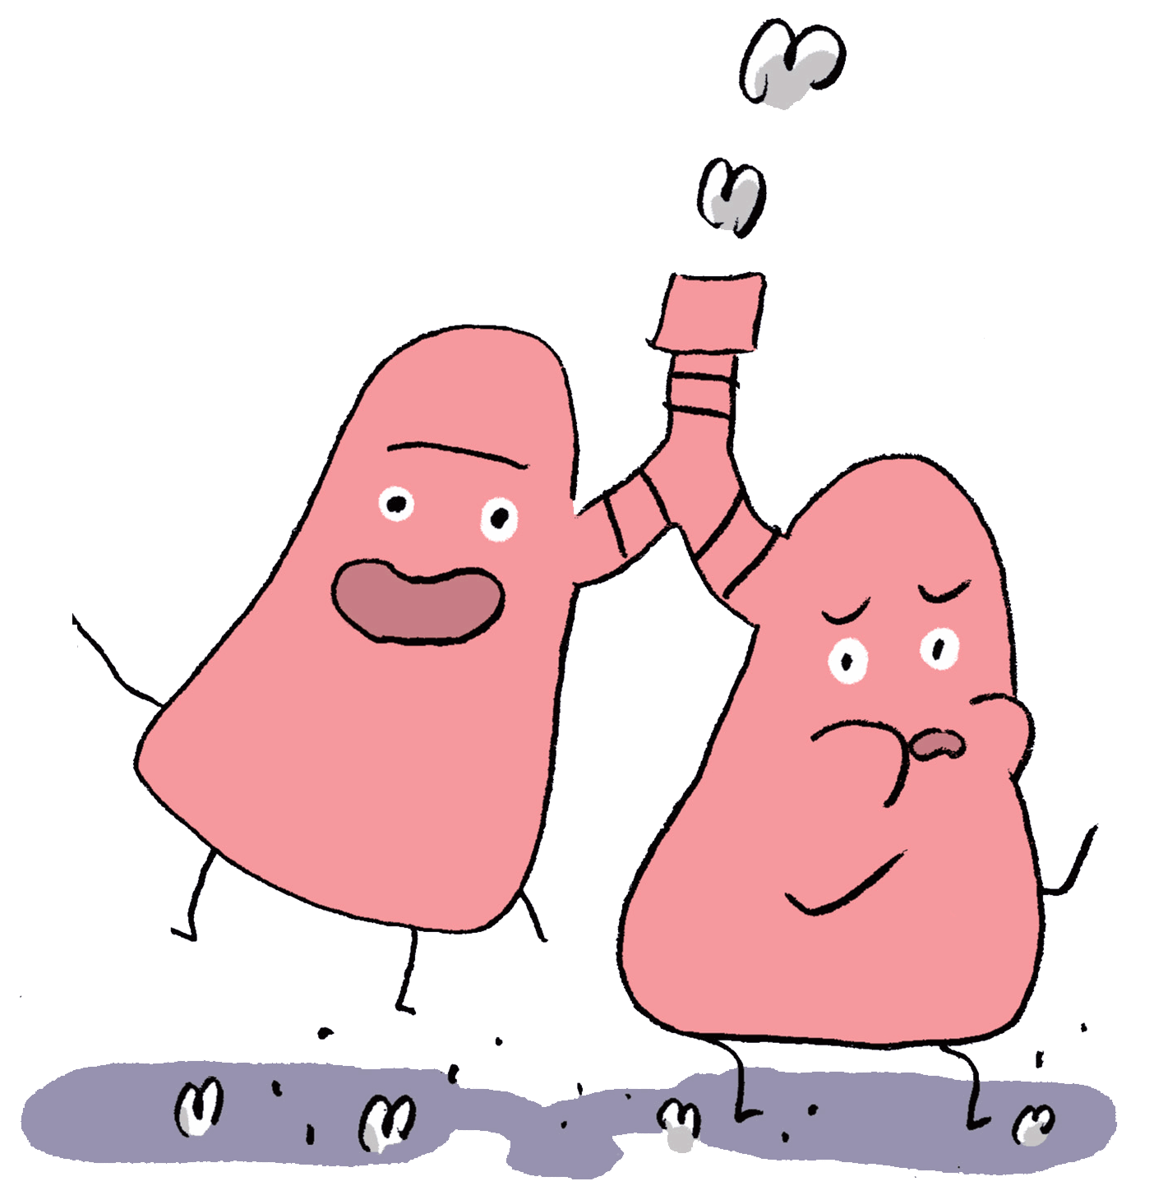
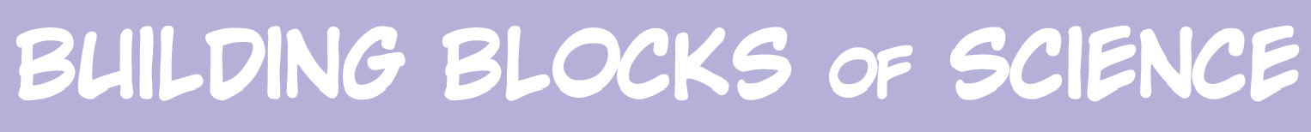
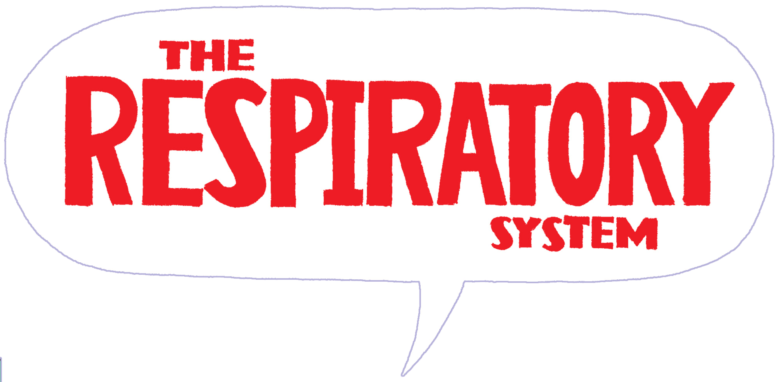

The Respiratory System Activity Sheet

1. The lungs are the main organs of the respiratory system. When you breathe in, you take in _________________________ from the air.
2. When you breathe out, you get rid of ___________________________________________.
3. The long tube by which air is carried to and from the lungs is called the trachea, or ______________________________.
4. What are the two tubes called that lead to the lungs?
____________________________________________________________________________
5. Without muscles and bones we would NOT be able to breathe.
a. True
b. False
6. The diaphragm is a dome-shaped sheet of muscle that separates the chest area from the ________________________________________.
7. Why is your nose so important in the breathing process?
____________________________________________________________________________________________________________________________________________________________________________________________________________________________________________________________________________________________________________________________________________________________________________________________
8. What sticky substance helps destroy dangerous germs and bacteria in your nose?
____________________________________________________________________________
9. Very fine hairs called cilia cover the inner surface of your nose. How do the fine hairs help to collect dust, bacteria, and mucus, and keep the nasal passages clean?
____________________________________________________________________________________________________________________________________________________________________________________________________________________________________
10. In each lung, the small tubes that branch off the bronchi are called __________________.
11. The alveoli, air sacs in the lungs, contain a network of tiny blood vessels and capillaries.
What is transferred through the walls of the alveoli into the bloodstream? ____________________________________________________________________________
12. Match the word to the meaning:
Answers: | Word: |  | Meaning:
 | 1. exhalation |  | A. | Breathing in
 | 2. inhalation |  | B. | The air that is breathed out of the lungs
 | 3. carbon dioxide |  | C. | Breathing out

13. Why is it easier to breathe at sea level than at higher altitudes?
____________________________________________________________________________
____________________________________________________________________________
____________________________________________________________________________
____________________________________________________________________________
14. Name three ways you can help keep your respiratory system healthy.
1. __________________________________________________________________________
2. __________________________________________________________________________
3. __________________________________________________________________________
ANSWERS:
1. Oxygen
2. Carbon dioxide
3. Windpipe.
4. Bronchi
5. True.
6. Abdomen.
7. The nose acts like a filter, cleaning the air before it passes down your throat into your lungs.
8. Mucus
9. The hairs wave back and forth, helping to collect the dust, bacteria, and mucus, and keep the nasal passages clean.
10. Bronchioles
11. Oxygen
12.
Answer: | Word:
C | 1. exhalation
A | 2. inhalation
B | 3. carbon dioxide

13. There is more than enough oxygen for humans to breathe easily at sea level but at higher altitudes, the air is thinner. High above sea level the lungs breathe more deeply and quickly even when at rest.
14. 1. Exercise
2. Eat well
3. Don’t smoke

