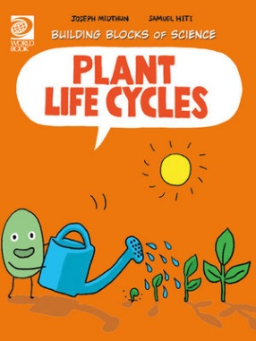
Plant Life Cycles Activity Sheet
- True or False: A seed is a living thing.
- What is a life cycle?
________________________________________________________________________
- Where does the life cycle begin?
________________________________________________________________________
- What is pollination?
________________________________________________________________________
- How do plants move their pollen to other plants?
________________________________________________________________________
- Name ways seeds travel?
________________________________________________________________________
- What is it called when a plant starts to grow?
________________________________________________________________________
- How long is a plant’s life span?
________________________________________________________________________
- What can cause disruptions in plant life cycles?
________________________________________________________________________
- How do plants affect your life cycle?
________________________________________________________________________

Answers:
- True
- A life cycle is the stages through which any organism passes during its lifetime.
- Reproduction
- Pollination is the process where a single particle of pollen must deliver sperm cells to the ovary. The egg is fertilised and a seed is produced.
- They produce a sweet nectar to attract birds and insects who get covered in pollen and then carries it to the next plant or flower it visits.
- Wind, float over water, or animals.
- Germination
- A plant’s life span is usually as long as a plant can live in the wild.
- Food shortages, lack of water, unfavourable growing conditions, diseases, pollution, invading species and parasites, humans and fires.
- Plants provide humans with oxygen to breathe, food to eat, shelter to keep us safe.

