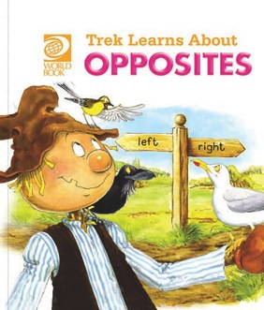
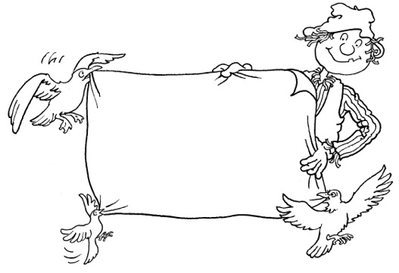
Trek’s Travels –

OPPOSITES

Talking about opposites
1. Why was it a bad day for Trek?
__________________________________________________________________________________________________________________________________
2. Why was it a bad day for Seagull?
__________________________________________________________________________________________________________________________________
3. Why was it a bad day for Wagtail?
__________________________________________________________________________________________________________________________________4. Why was it a bad day for Crow?
__________________________________________________________________________________________________________________________________
5. Was Trek’s hat new or old?
_________________________________________________________________
6. Did Seagull look beautiful or ugly?
_________________________________________________________________7. Was Wagtail’s song happy or sad?
_________________________________________________________________
8. Did Crow find a quiet place or a noisy one?
_________________________________________________________________

9. Can you think of the opposite of right?
_________________________________________________________________
10. Can you think of the opposite of straight?
_________________________________________________________________11. Can you think of the opposite of dry?
_________________________________________________________________12. Can you think of the opposite of fat?
_________________________________________________________________13. Do you have bad days like Trek and his friends?
_________________________________________________________________

ACTIVITY –

Match the opposites from the word lists below.

List one | List two
clean | old
hot | full
empty | wet
new | dirty
dry | last
first | cold

ACTIVITY –

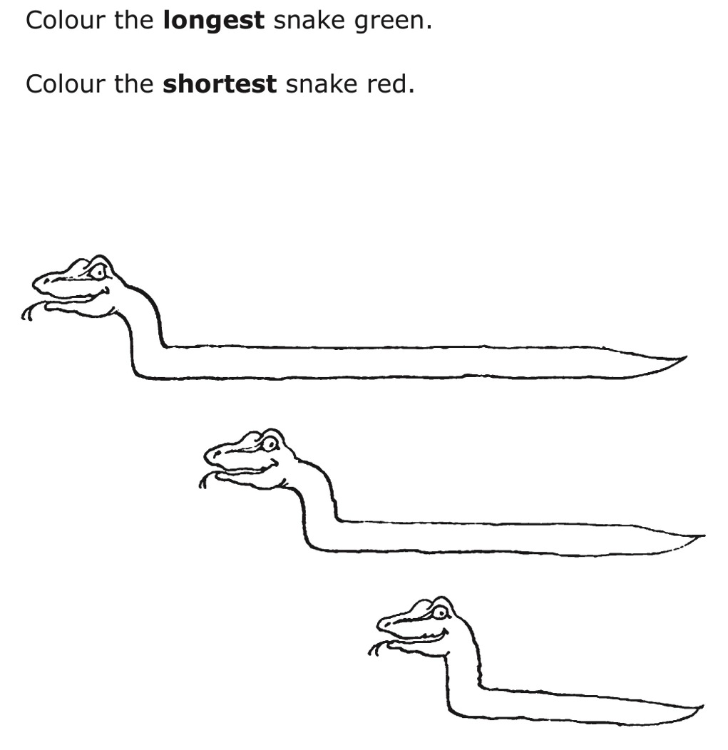

Aim: to understand the language of opposite.
Trek’s World Travels
Where in the world does Trek learn about opposites?
United Kingdom and Ireland

