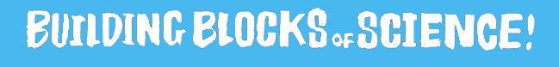
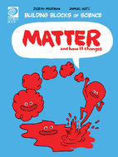

Matter and How It Changes Activity Sheet
- What is matter?
________________________________________________________________________________
- Name the three basic states of matter?
________________________________________________________________________________
- What causes matter to change states?
_________________________________________________________________________
- True or false: The state of all matter depends on its temperature.
- True or false: Matter cannot change back and forth between states.
- Why does rain turn to snow?
________________________________________________________________________________
- What kind of change has a tree gone through to become a piece of a paper?
________________________________________________________________________________
- If salt in ocean water is mixed evenly and will not settle at the bottom of the ocean, like sand, how do you separate salt from ocean water?
________________________________________________________________________________
- What kind of change occurs to wood when it is burned?
________________________________________________________________________________
- Fill in the blanks: Something is changing chemically if it ____________________ or if it is on ________.
- What is an example of chemical change?
________________________________________________________________________________
- What examples can you think of where you see matter change in your everyday life?
________________________________________________________________________________

ANSWERS:
- Everything in the world is made of matter. Matter is made up of tiny particles called atoms.
- Solids, liquids, and gases.
- Energy. Energy has the ability to cause change.
- True
- False
- If it is cold enough outside, rain can freeze as it falls, changing from a liquid into a solid – snow.
- The tree has gone through a physical change.
- To separate the salt from the water, we need to wait for the sun to evaporate the water.
- A chemical change.
- Fill in the blanks: Something is changing chemically if it changes colour or if it is on fire.
- When humans, plants and animals eat food.
- Steam in the shower, smoke from a fire, when cooking e.g. baking.

