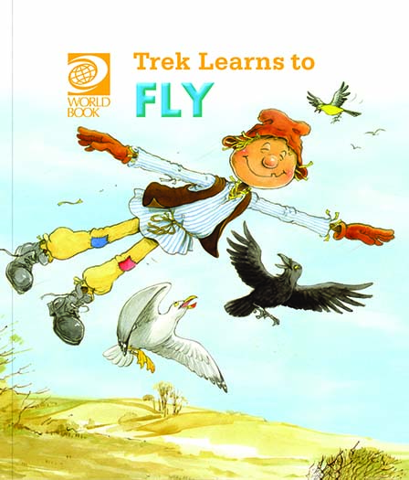
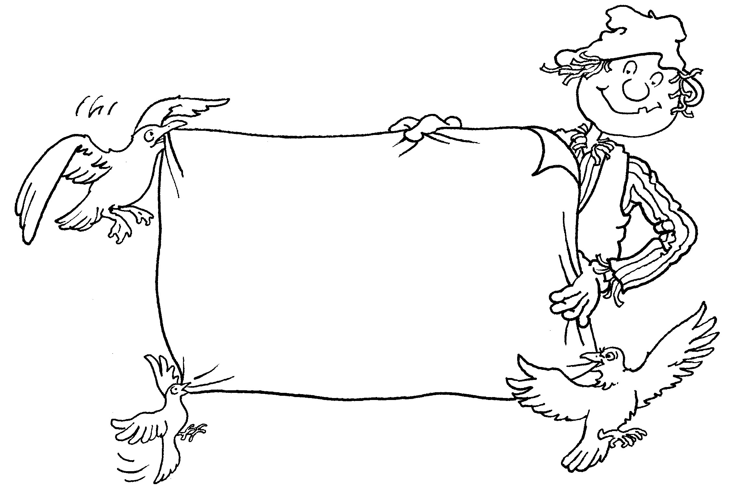
Trek’s Travels –

TREK LEARNS TO FLY

All about Trek
1. Do you know what a scarecrow is?
_________________________________________________________________
2. Have you ever seen a scarecrow?
_________________________________________________________________
3. Did the scarecrow look like Trek?
_________________________________________________________________4. Can you remember what clothes Trek is wearing?
_________________________________________________________________
Find and colour the things which belong to Trek.
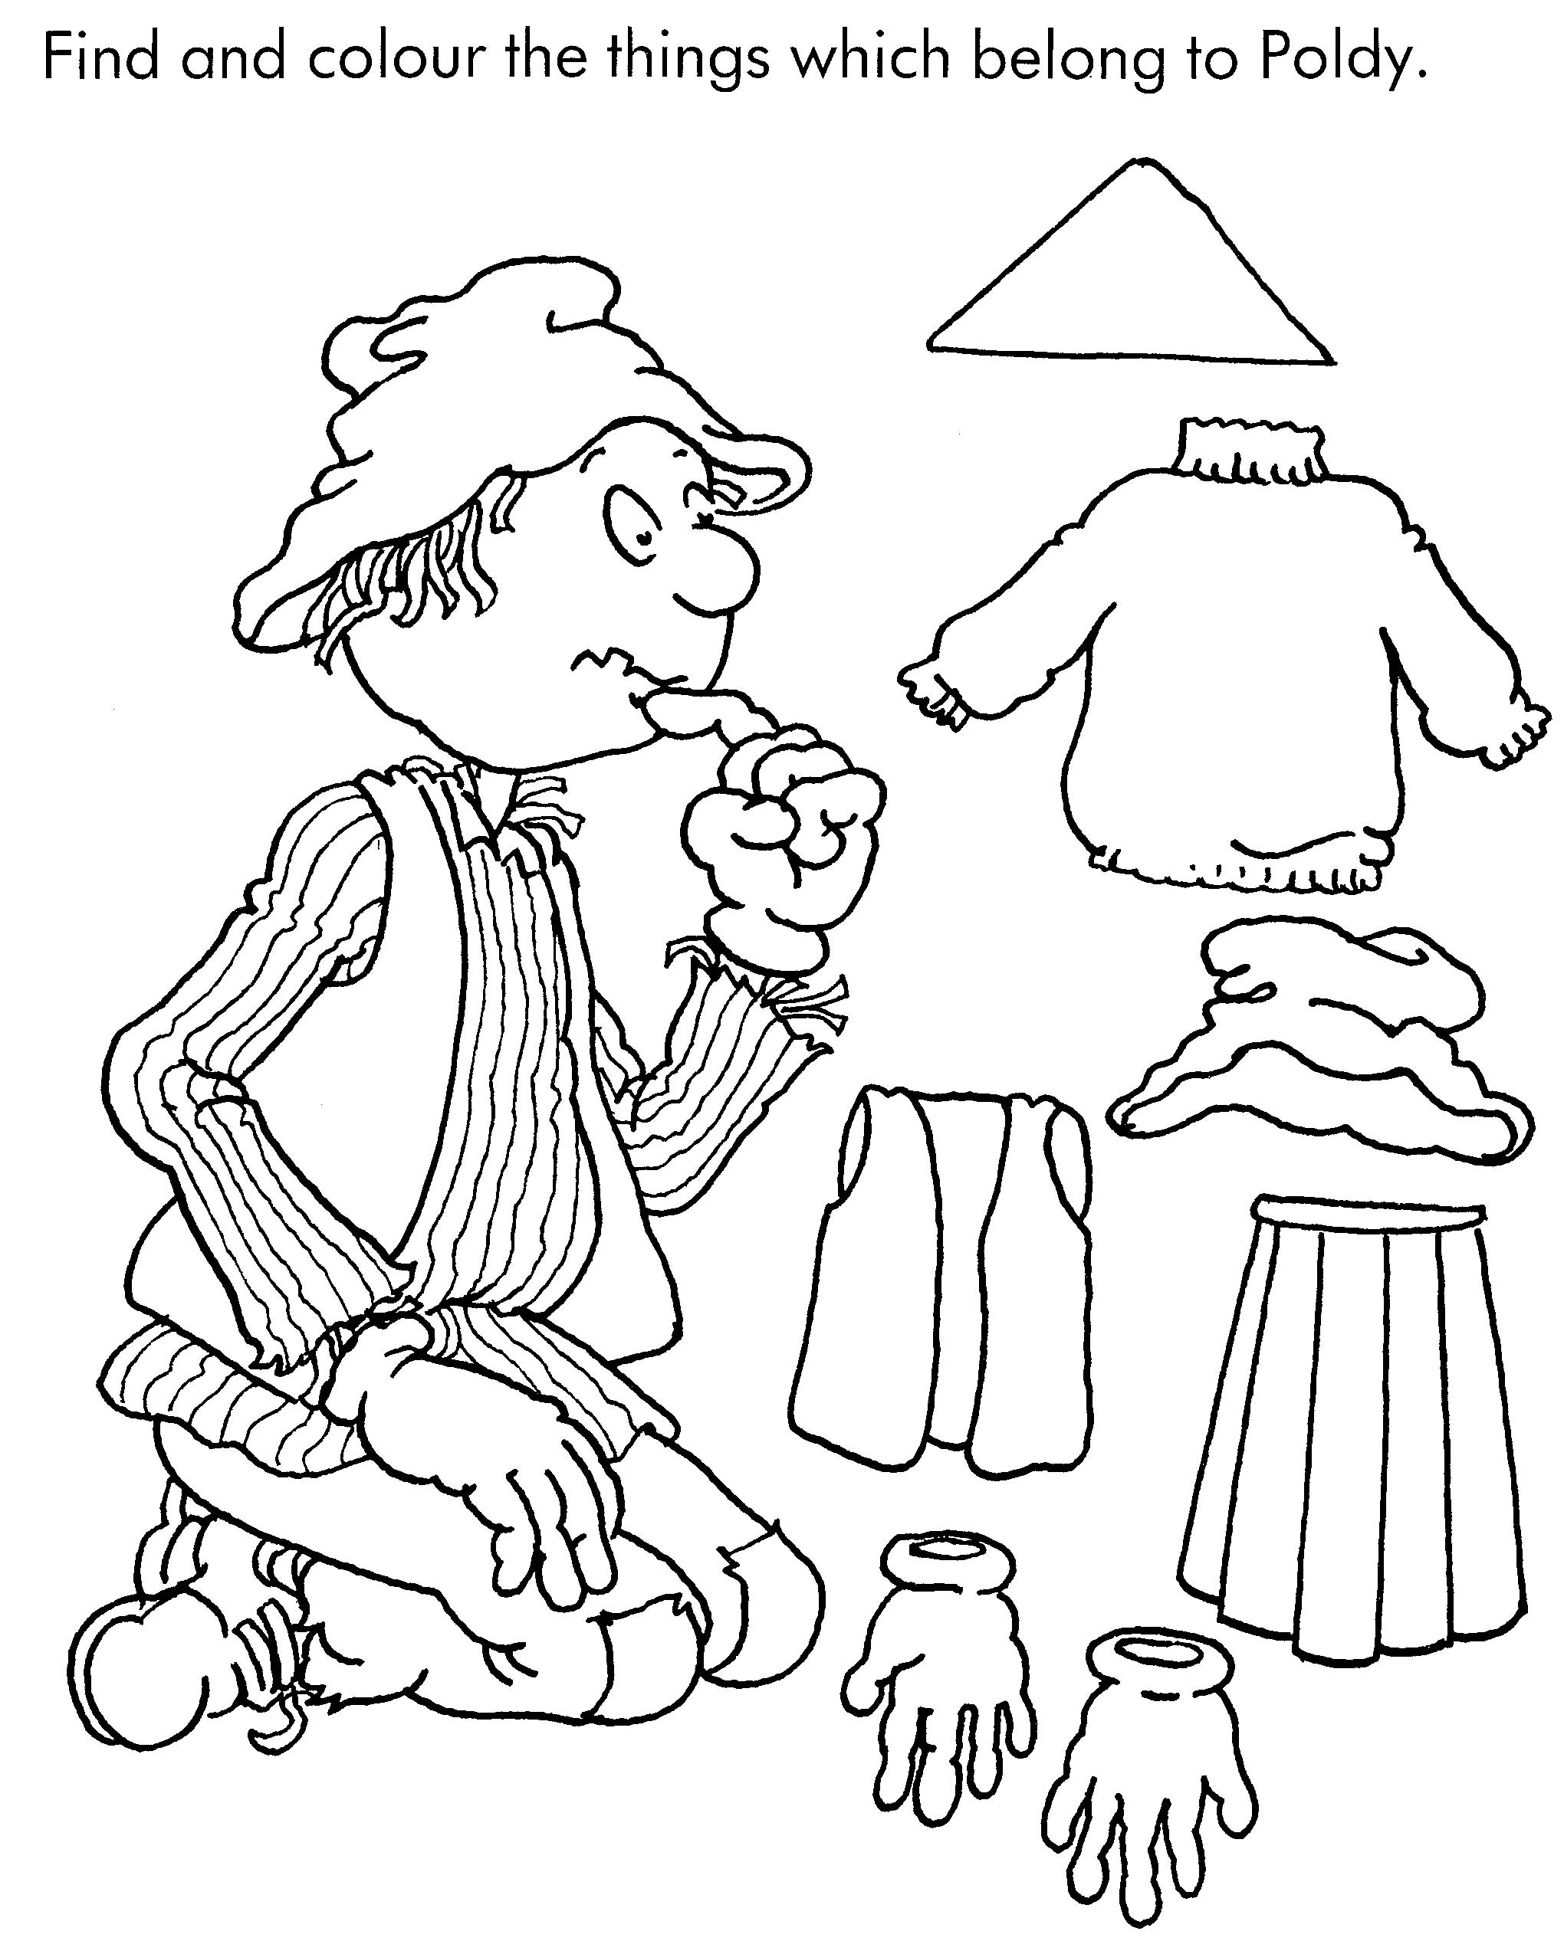
The seasons of the year
1. How many seasons do we have?
_________________________________________________________________
2. What are the names of the seasons?
_________________________________________________________________3. What season is it now?
_________________________________________________________________
Wagtail, Crow and Seagull
1.
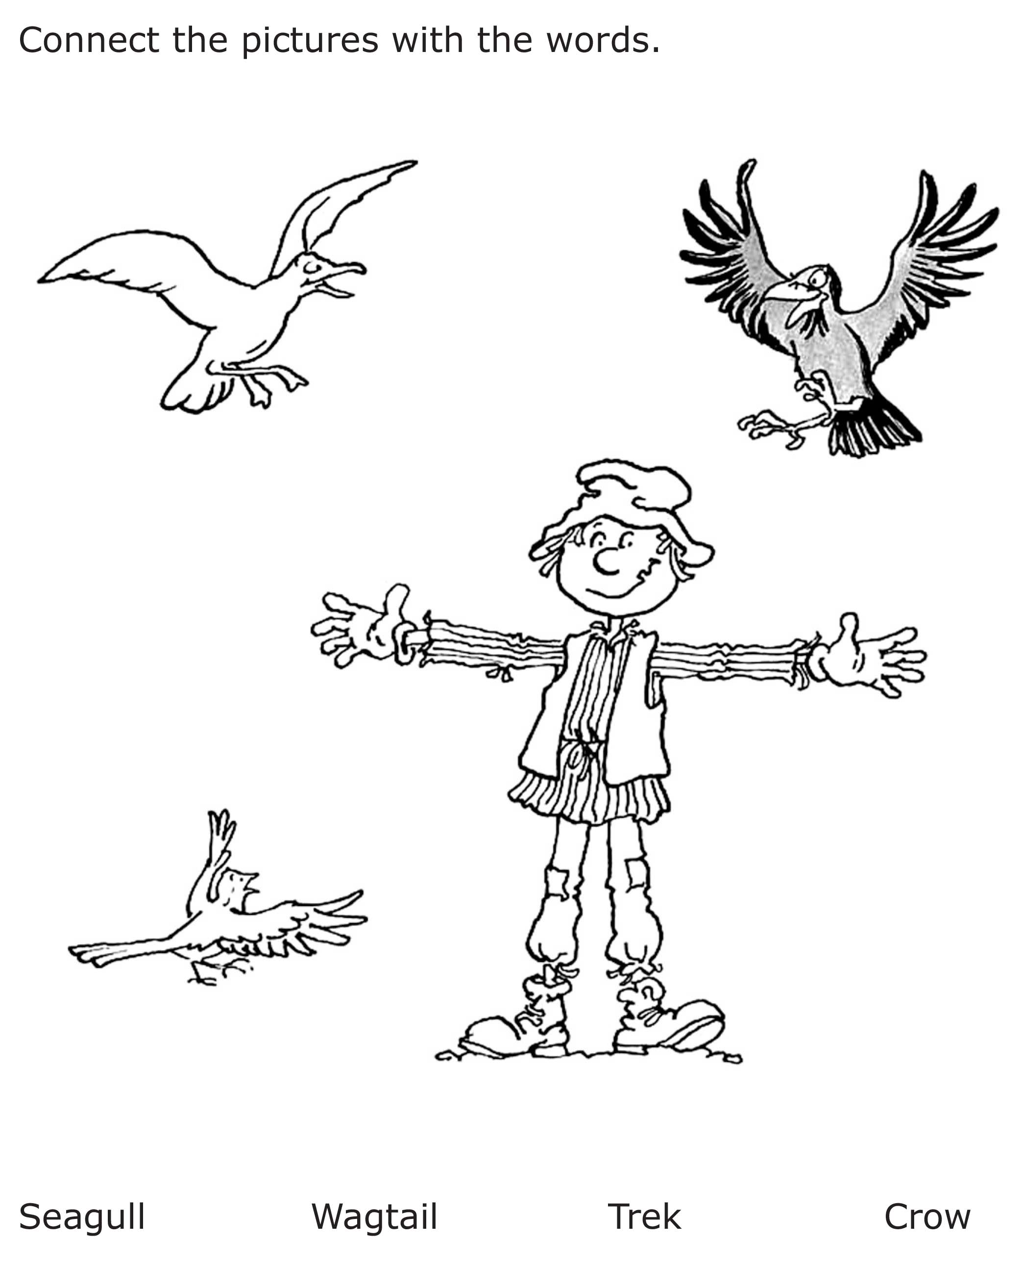
2. Is Crow the same size as Wagtail?
_________________________________________________________________
3. Is Seagull the same colour as Crow?
_________________________________________________________________
ACTIVITY – How does Trek learn to fly? Look at these four pictures.
Now tell what’s happening in each of them.

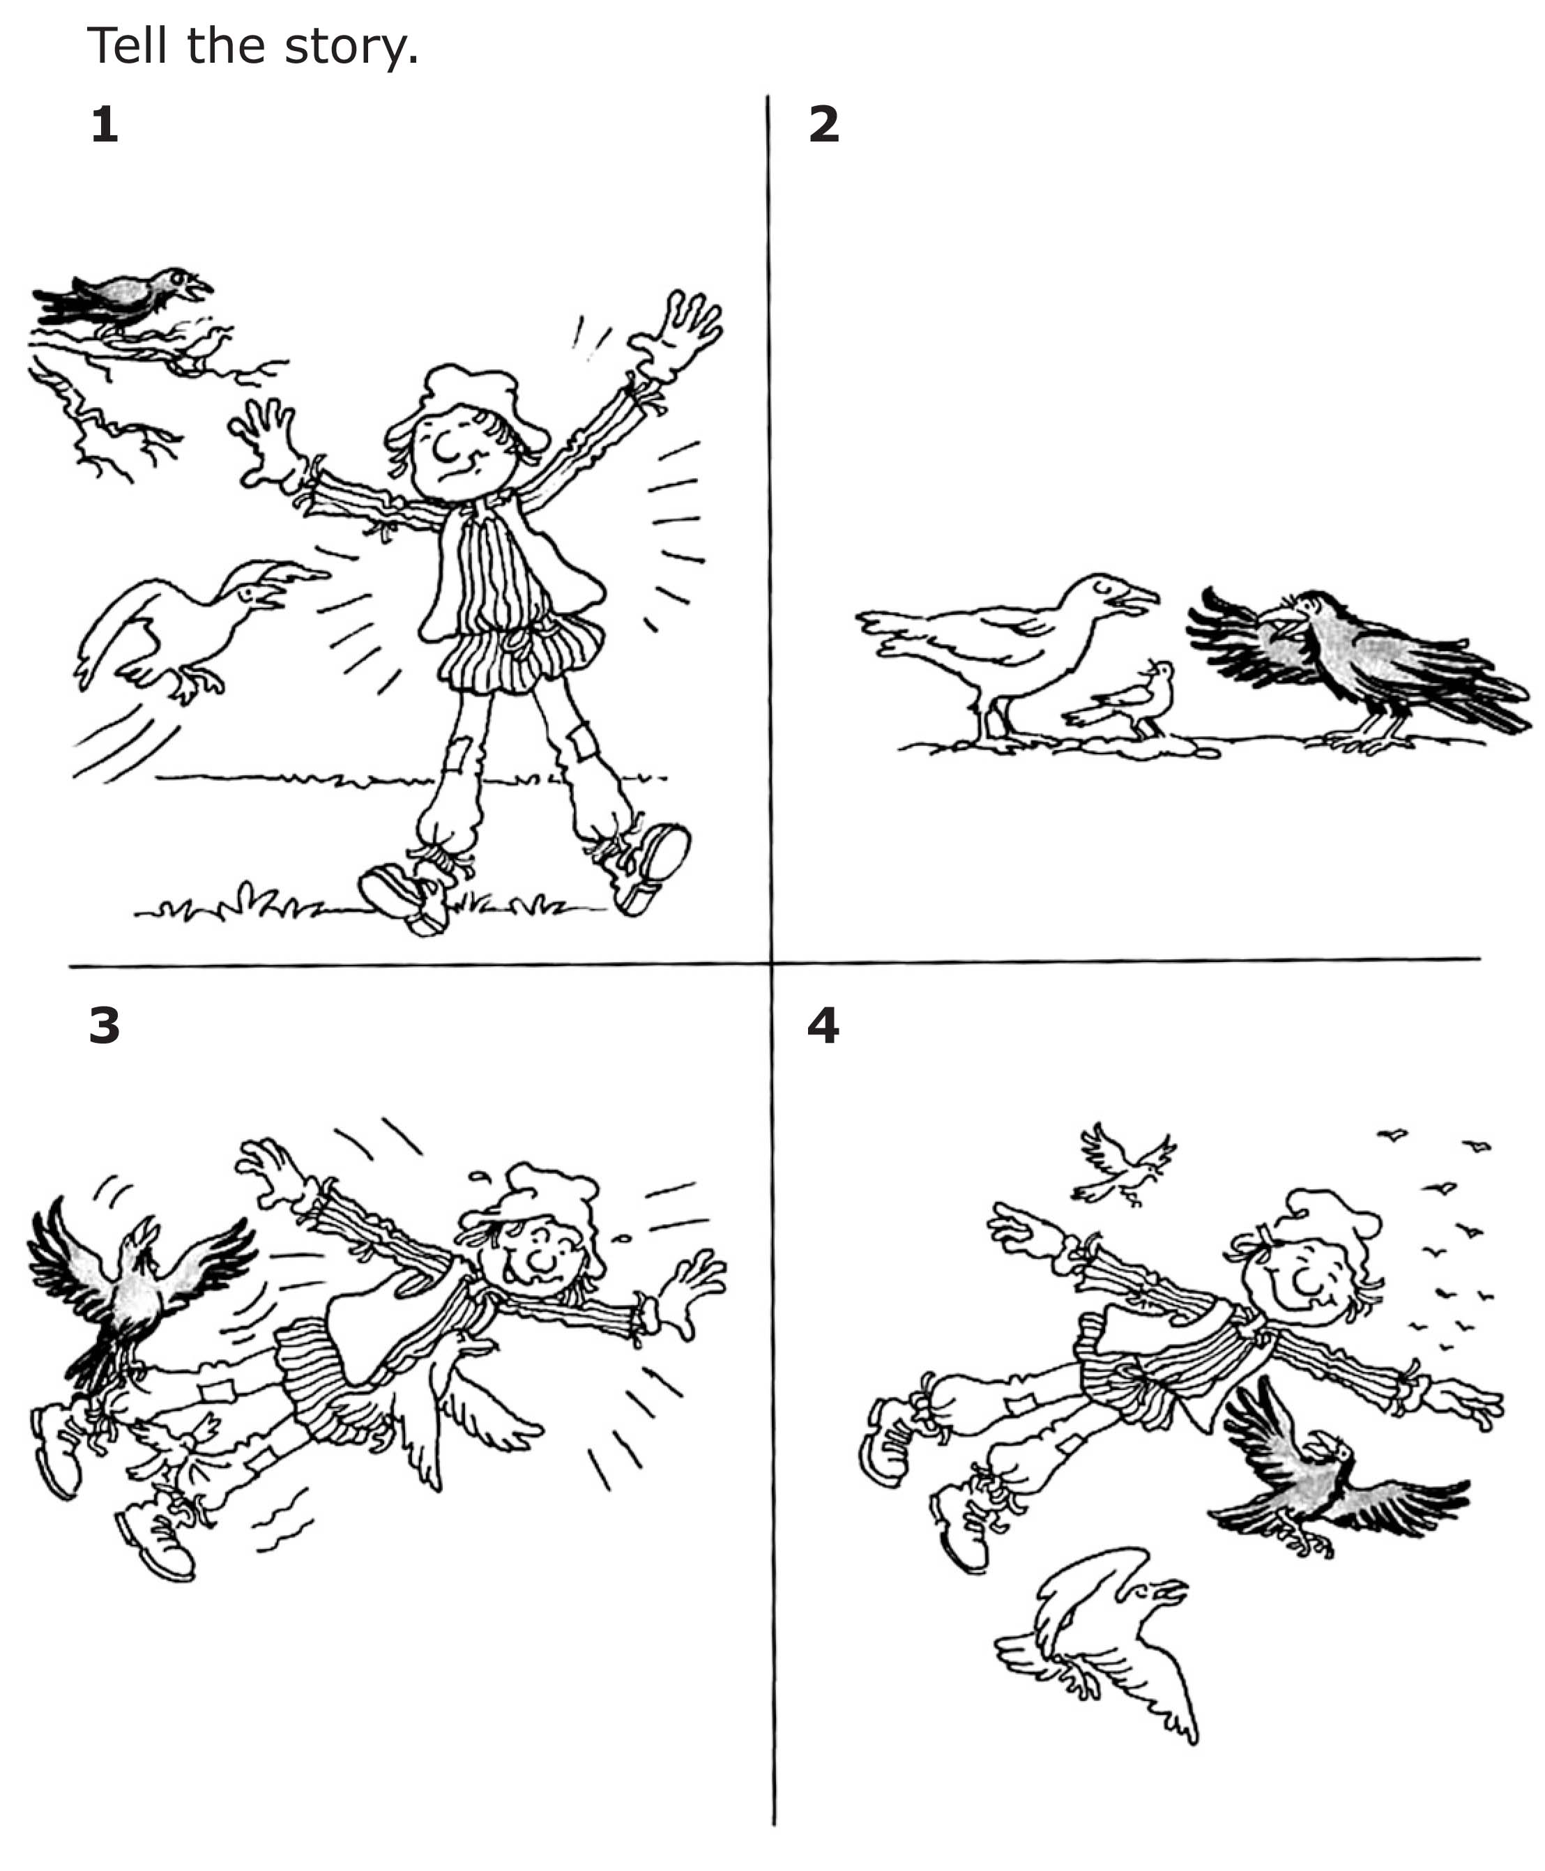

Aim: to tell a story in sequence.

Trek’s World Travels
Where in the world does Trek learn to fly?
Northern Europe
