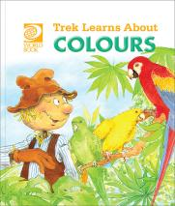
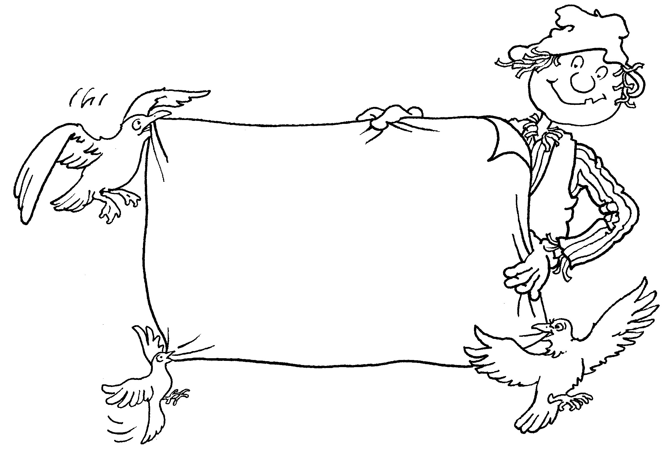
Trek’s Travels –

COLOURS

All about the forest
1. Do you know what a forest is?
_________________________________________________________________
2. Have you ever been in a forest?
_________________________________________________________________
3. Is it dark there?
_________________________________________________________________
4. Why do you think it is dark?
_________________________________________________________________
5. Can you think of any other dark places?
_________________________________________________________________6. What can we do to make a dark place lighter?
_________________________________________________________________

All about parrots
1. Did you like the parrots?
_________________________________________________________________
2. Why did you like them?
_________________________________________________________________
3. What colours are the parrots’ feathers?
_________________________________________________________________4. Can you think of any other colourful animals?
_________________________________________________________________

ACTIVITY –

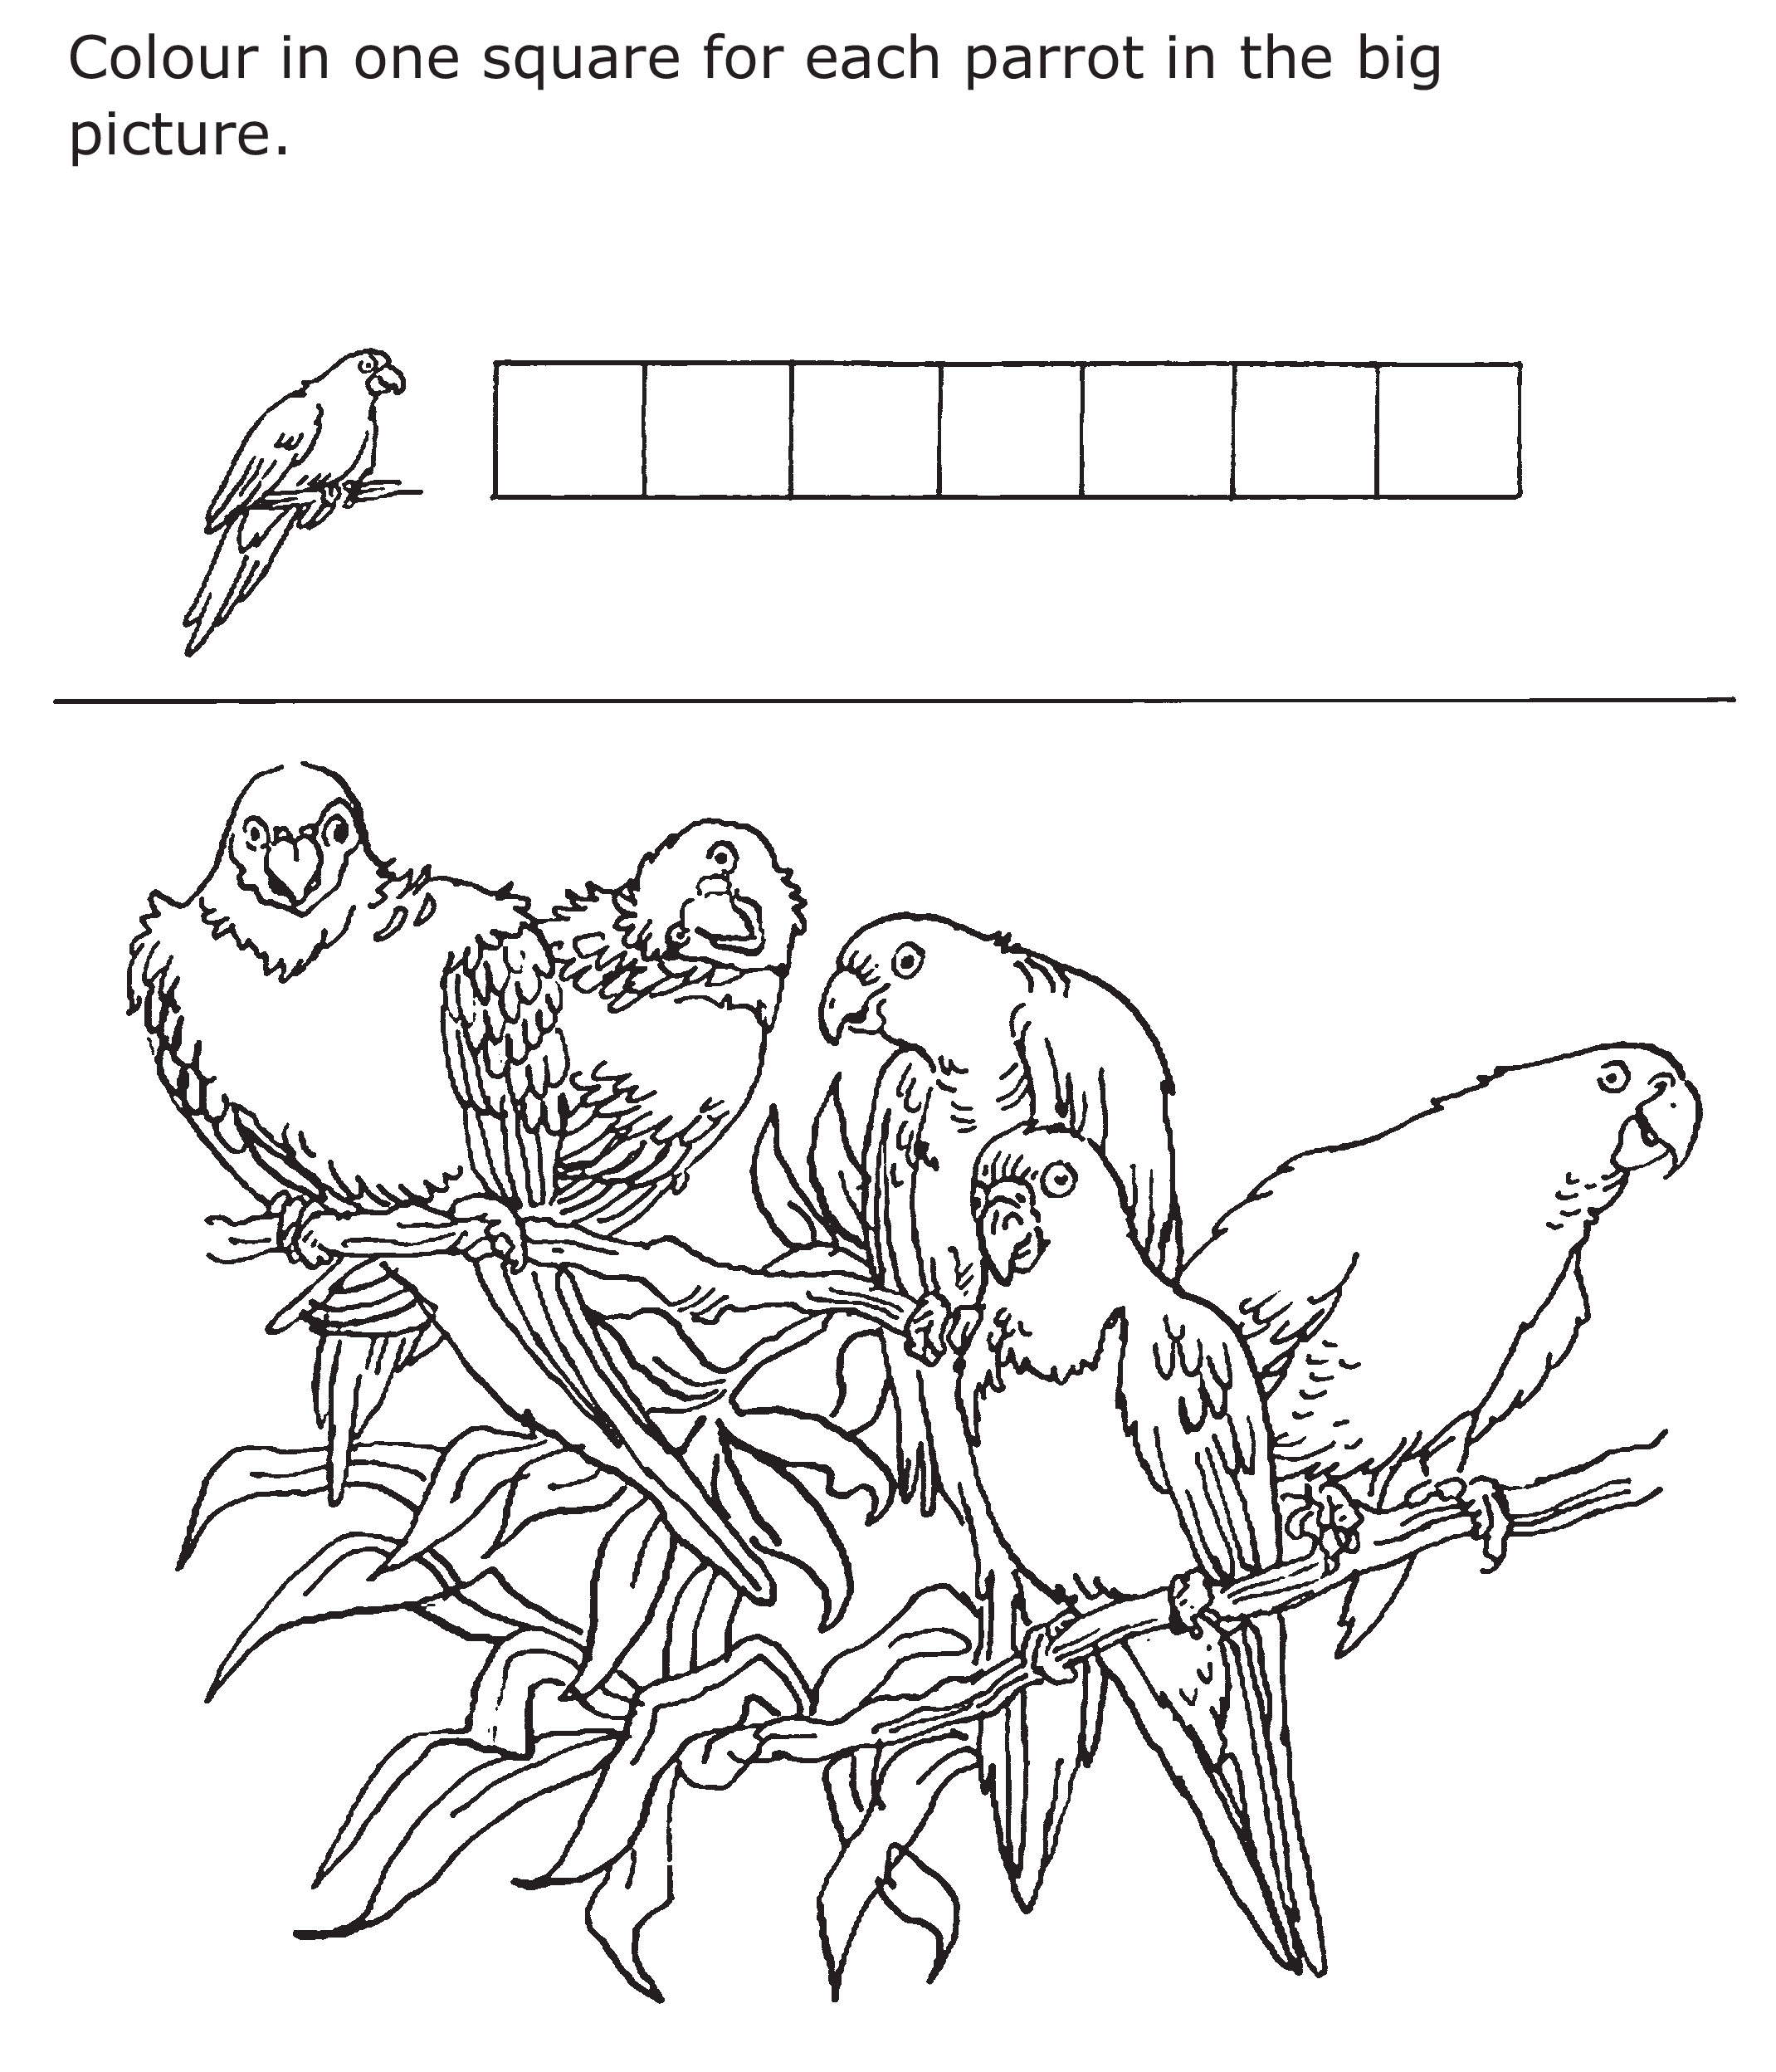

Aim: to practise counting and recording results.

ACTIVITY –

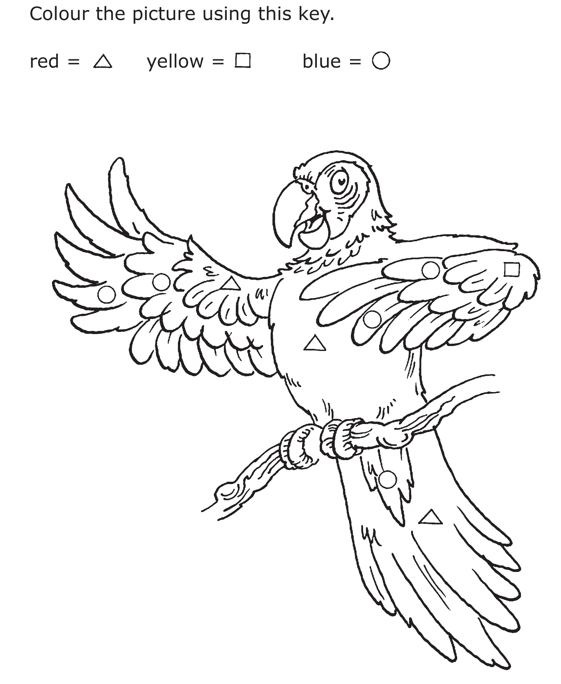

Aim: to recognise colours and learn to follow a key.

Trek’s World Travels
Where in the world does Trek learn about colours?
South America

