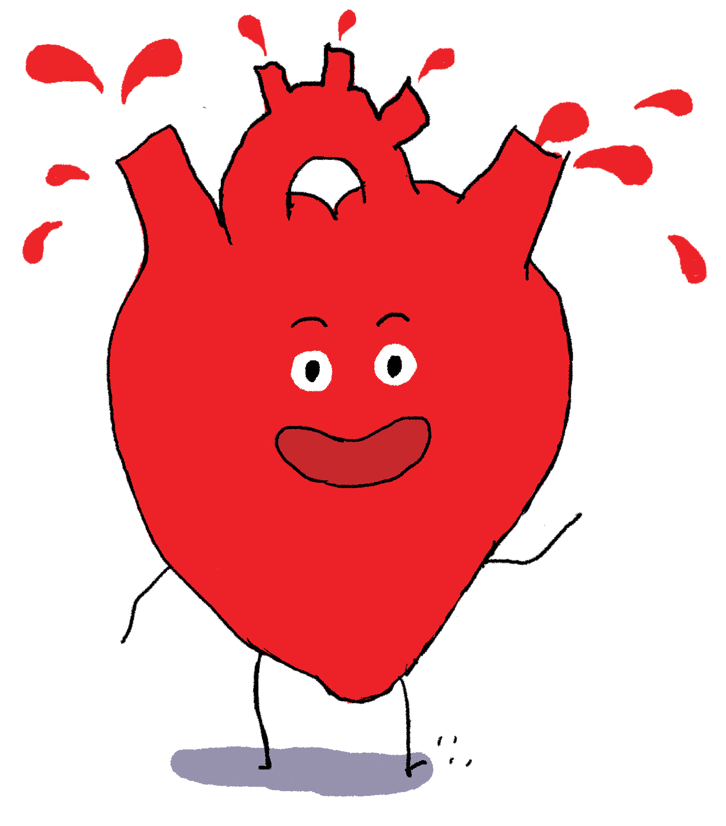
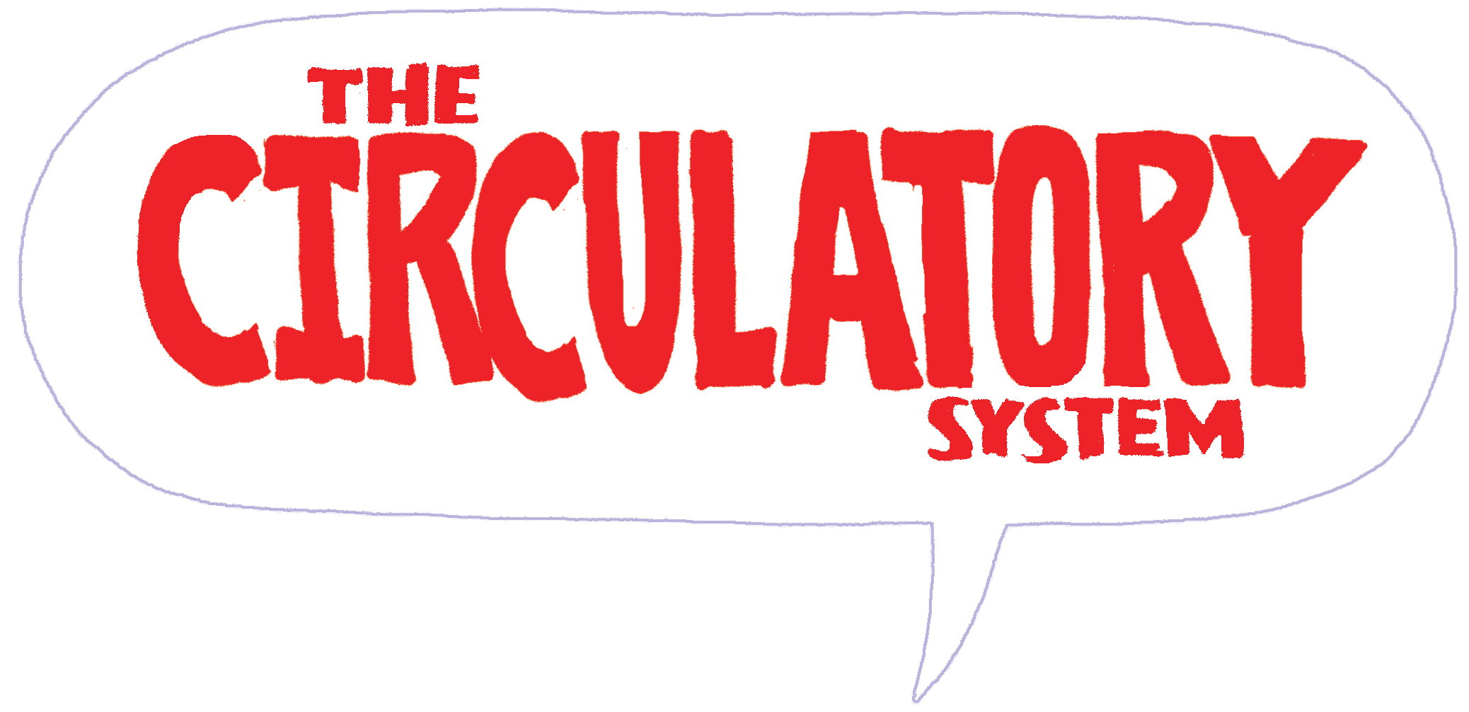

The Circulatory System Activity Sheet

1. Which of the following is NOT one of the three main components of the circulatory system?
a. Heart
b. Lungs
c. Blood
d. Blood vessels
2. More than half of your blood is made of a liquid called _____________________________.
3. Each type of blood cell has a different job. Explain the job that each does.
Red blood cells: _______________________________________________________________
__________________________________________________________________________________________________________________
__________________________________________________________________________________________________________________
Platelets: ____________________________________________________________________
__________________________________________________________________________________________________________________
__________________________________________________________________________________________________________________
White blood cells: _____________________________________________________________
__________________________________________________________________________________________________________________
__________________________________________________________________________________________________________________
4. Blood vessels that carry blood FROM the heart to the body are called _________________.
5. Blood vessels that carry blood TO the heart from the body are called _________________.
6. Name two substances that move from the blood into cells as the blood flows through the capillaries.
_____________________________________ _____________________________________
7. The main artery of the body is called the ________________________________________.
8. There are two pumps in the heart. The left side delivers oxygen rich blood to the body from the lungs through the arteries. The right side pumps the blood carrying what waste gas out of the body into the lungs through the veins? ___________________________________
9. What organ stores energy in the body and releases nutrients into the blood when needed? ____________________________________________________________________________ 10. When your body temperature begins to rise, the flow of blood to the skin increases and then the heat passes out of the body. What happens when your body temperature drops?
________________________________________________________________________________________________________________________________________________________
____________________________________________________________________________
____________________________________________________________________________
11. Blood pressure is the force of blood moving through the body. What is high blood pressure called? _____________________________________________________________
12. THE HUMAN HEART: Match the labels -
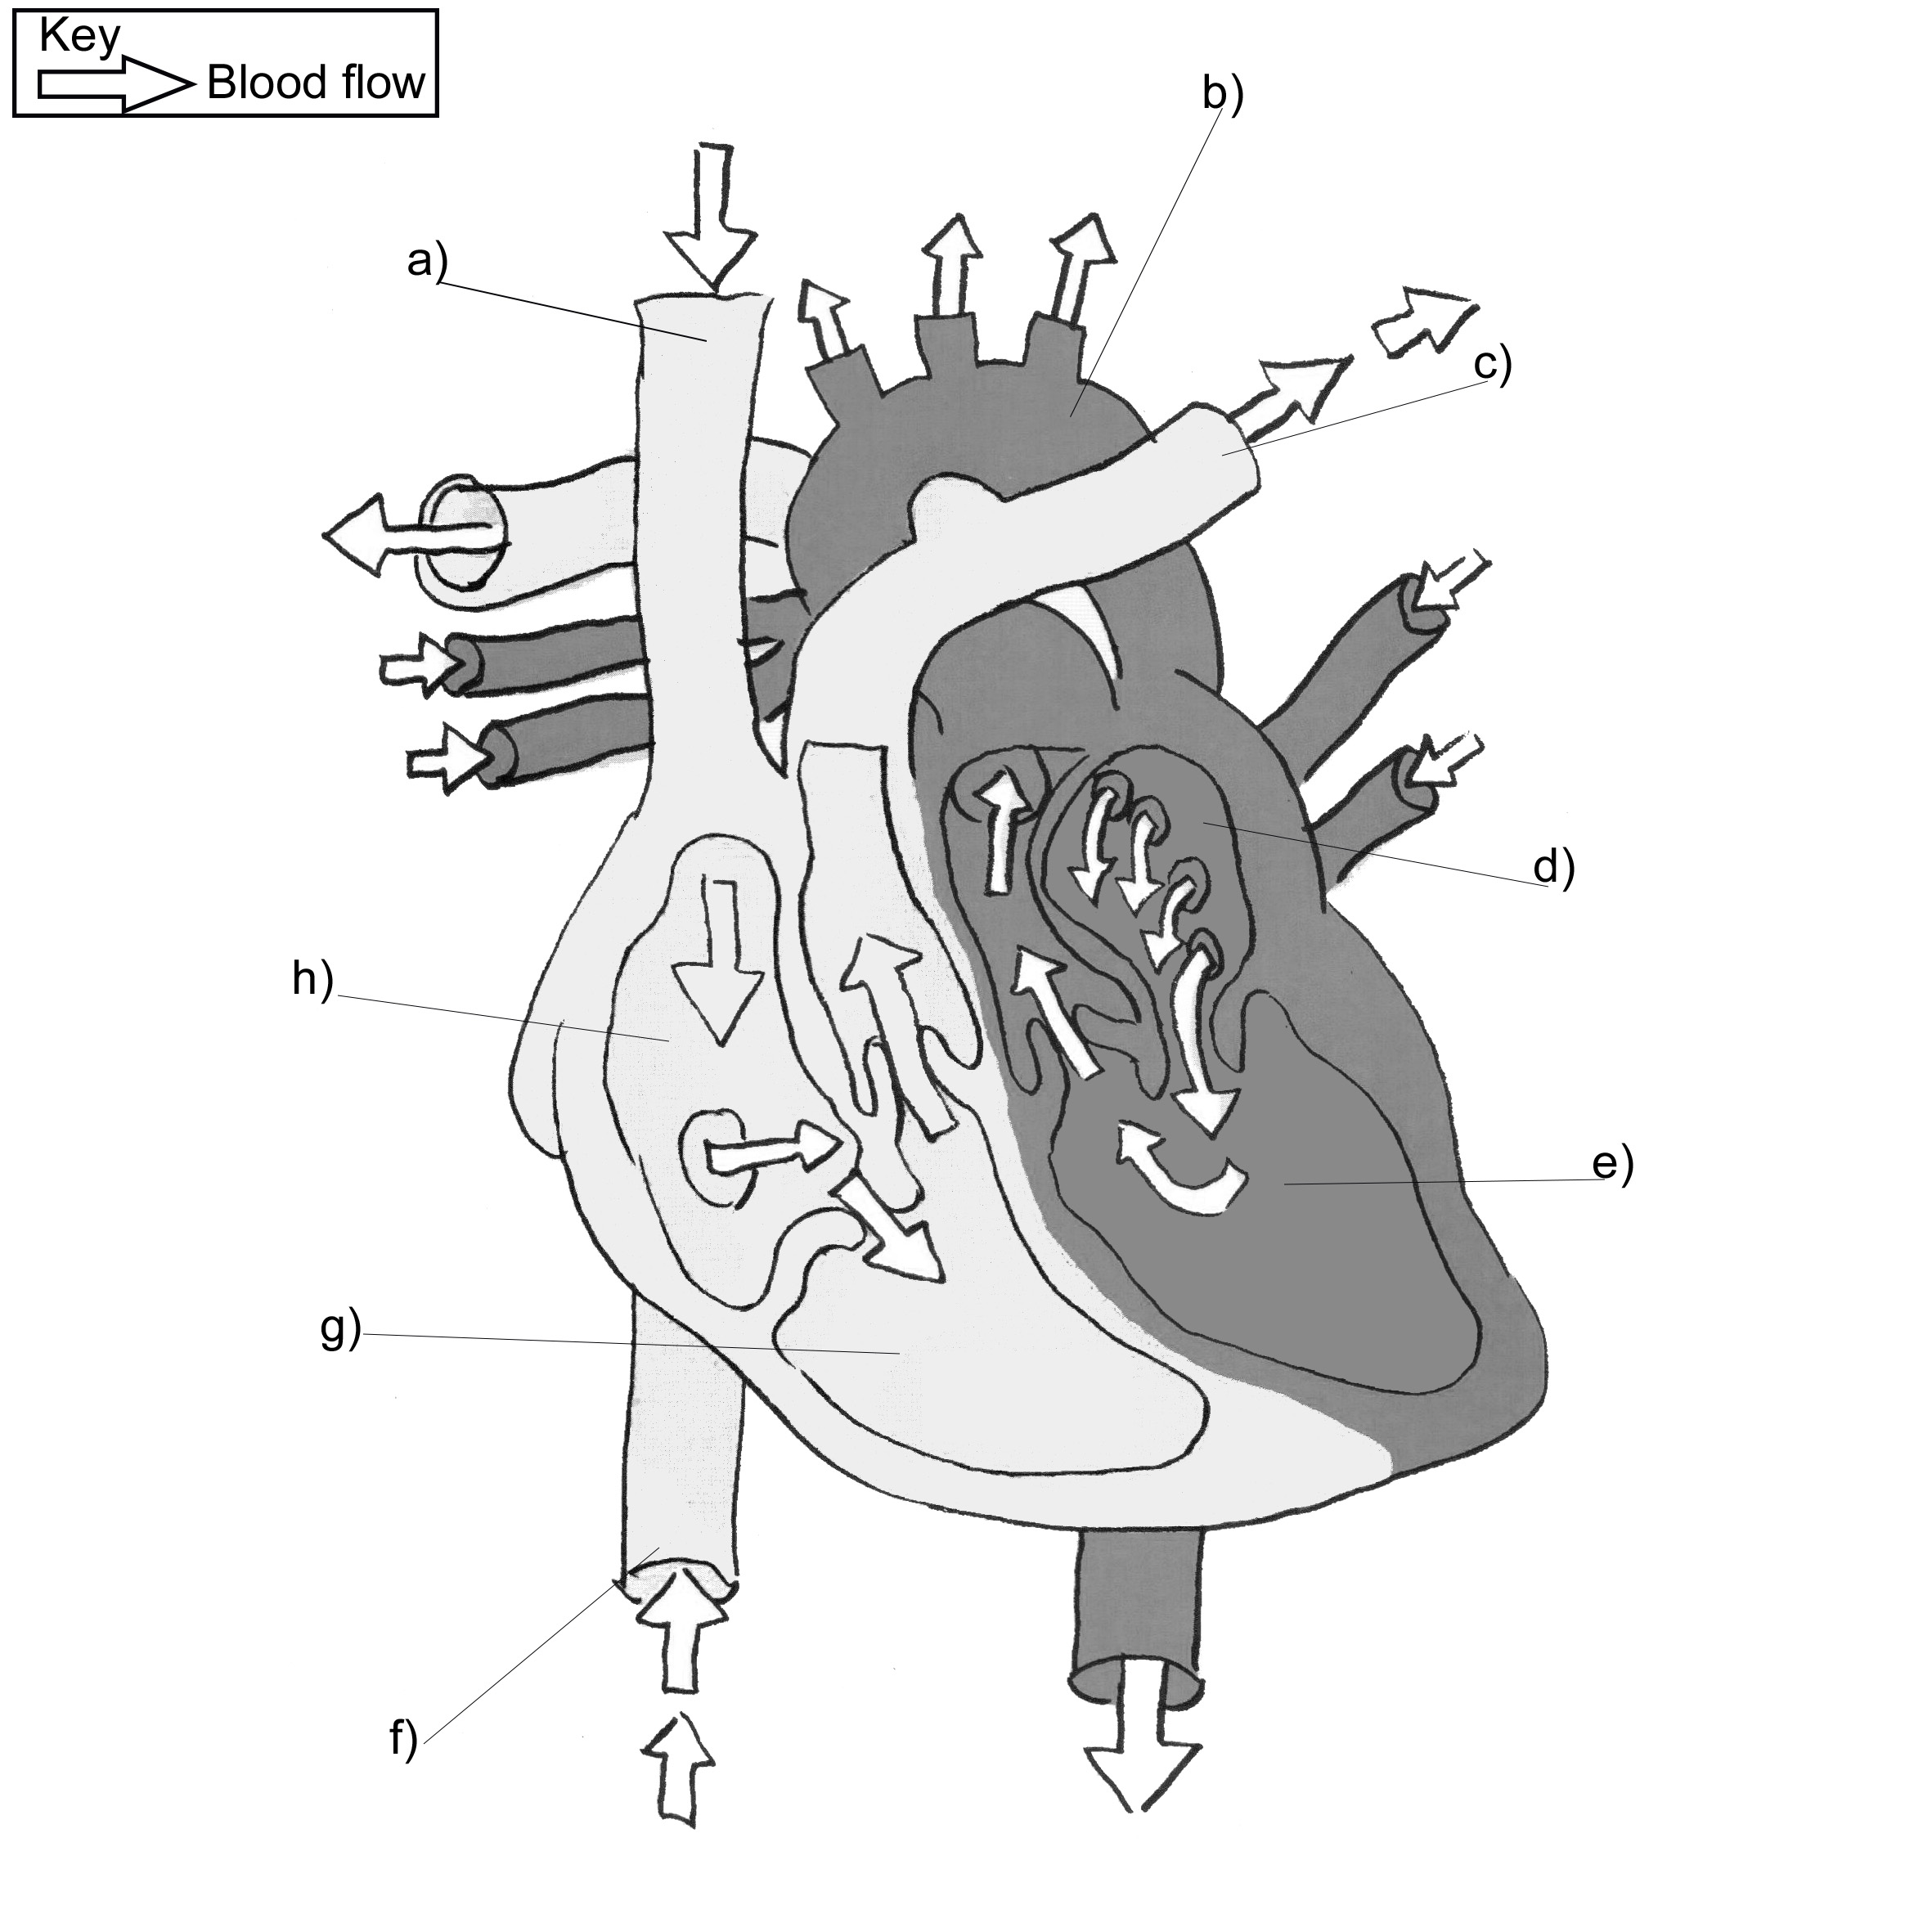
______ aorta | ______ pulmonary artery
______ right atrium | ______ left atrium
______ right ventricle | ______ right ventricle
______ inferior vena cava | ______ superior vena cava
ANSWERS:
1. b. lungs
2. Plasma
3. Red blood cells transport oxygen throughout your body.
Platelets help stop bleeding at the site of a wound.
White blood cells defend the body against illness.
4. Arteries
5. Veins
6. Oxygen, nutrients
7. Aorta
8. Carbon dioxide
9. Liver
10. When your body temperature begins to drop, the flow of blood to the skin is restricted helping the body to retain as much heat as possible.
11. Hypertension
12.
___b)___ aorta | ___c)___ pulmonary artery
___h)___ right atrium | ___d)___ left atrium
___g)___ right ventricle | ___e)___ left ventricle
___f)___ inferior vena cava | ___a)___ superior vena cava

