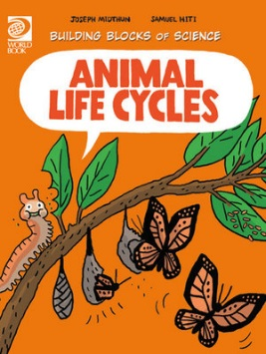
Animal Life Cycles Activity Sheet

- What is the life cycle?
_________________________________________________________________________
- Where does every life begin?
_________________________________________________________________________
- Name animals where the eggs can be fertilised out of the body.
_________________________________________________________________________
- Name animals where the eggs are laid containing offspring (fertilised).
_________________________________________________________________________
- Why do some animals have more offspring than others?
_________________________________________________________________________
- True or false? Parental care varies between animal species.
- Name some different ways that animals’ bodies develop into their adult bodies.
___________________________________________________________________________________________________________________________________________________________________________________________________________________________
- What is the transformation that a frog or insects goes through called?
_________________________________________________________________________
- What does a caterpillar wasp use a caterpillar for?
_________________________________________________________________________
- What is a life span?
_________________________________________________________________________
- Match the animal with their life span.
Tortoise |  | 1 week
Humans |  | 24 hours
Squirrels |  | 150 years
Moth |  | 70 – 80 years
Mayfly |  | 10 years
- What is a common threat to an animal’s life span?
_________________________________________________________________________
- What is a life cycle disruption?
_________________________________________________________________________
_________________________________________________________________________
- What can cause life cycle disruptions?
__________________________________________________________________________________________________________________________________________________
- Why is it called a life cycle?
_________________________________________________________________________
ANSWERS:
- Life cycles are different stages all living things go through as they grow and develop.
- Every life begins with reproduction.
- Newts and fish e.g. salmon.
- Chickens, crocodiles, ducks, platypus and echidna.
- Fish, for example, have many offspring because most will not survive to adulthood.
- True.
- Crabs shed their outer shell covering, cheetahs lose their baby teeth and grow new adult ones. Penguins grow thick feathers.
- Metamorphosis.
- To reproduce. A caterpillar wasp lays their eggs inside the caterpillar.
- A life span is a measure of how long an animal typically lives in the wild.
- Tortoise – 150 years
Humans – 70-80 years
Squirrels – 10 years
Moth – 1 week
Mayfly – 24 hours
- Predation.
- When an animal dies much younger than their expected life span.
- Food shortages, invasive species, diseases, habitat destruction, lack of water, pollution and even tiny parasites.
- Every life cycle comes to an end but at the end, there is a new life cycle beginning. It is called the circle of life.

