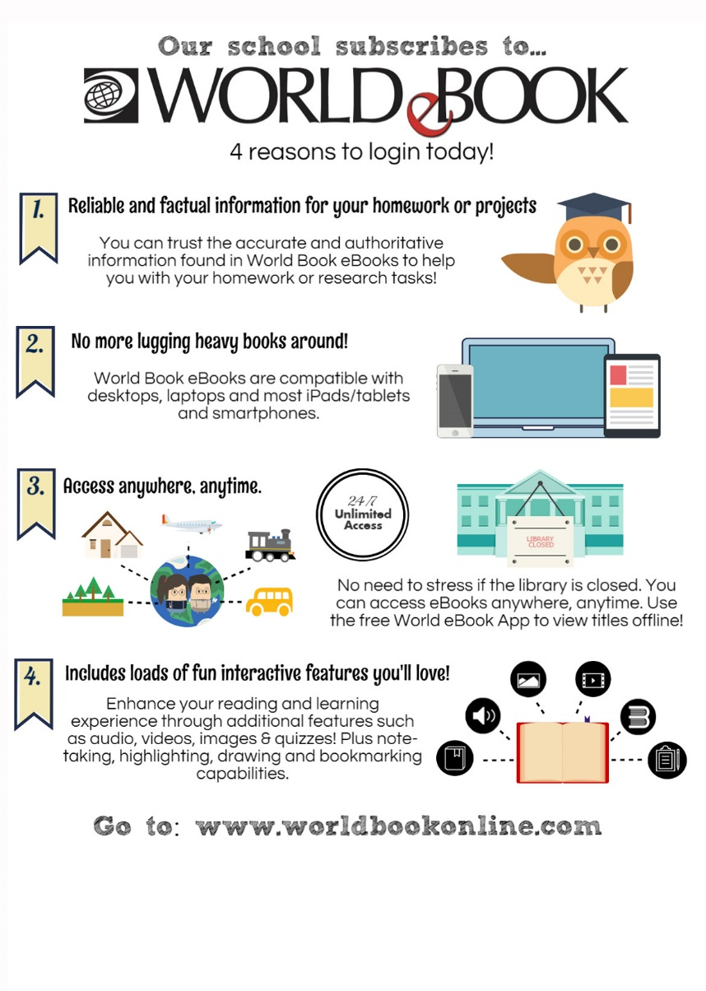

**Our library subscribes to World eBooks. Login via your library’s digital resources page!**