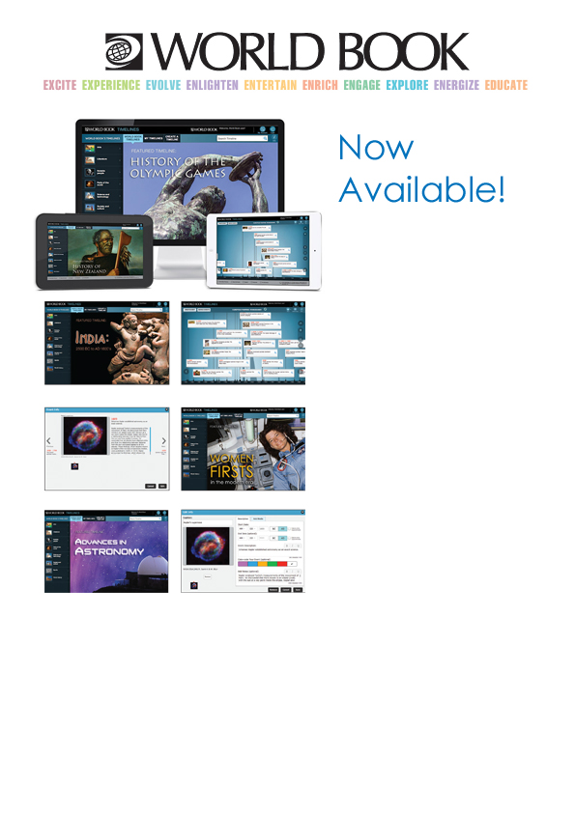

I:\Sue\Timelines\timelines.gif

**LOOK FOR THIS ICON ON YOUR WORLDBOOK ONLINE HOMEPAGE**

**WITH WORLD BOOK   
STUDENT, ADVANCED  
AND DISCOVER**

* **Browse 500+ unique *Timelines*** spanning the arts, science and technology, society and culture, sports, world history, geography and more!
* **Create, customise, collaborate, and share** your timelines
* Use more than **13,000 events** built into the product
* **Includes historical notes, and a** wealth of engaging **images and videos** to craft stunning presentations
* Integrated with World Book’s **My Research accounts**
* Integrated with **Google Classroom**
* Great for **visual learners**
* Perfect for **all ages**
* **Supported on most popular Tablets and Handheld Devices**

**GO TO: Insert URL**

**LOG-IN ID: Insert ID**

**PASSWORD: Insert PASSWORD**